**Task:** 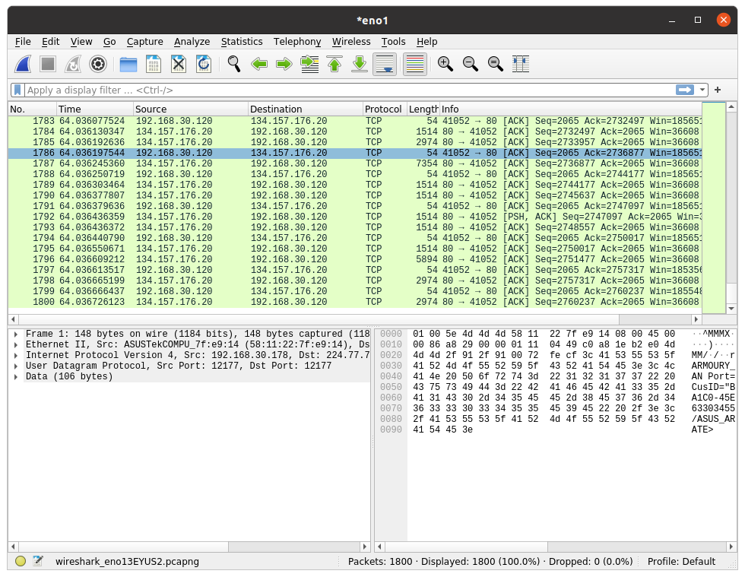

1. The Basic HTTP GET/response interaction

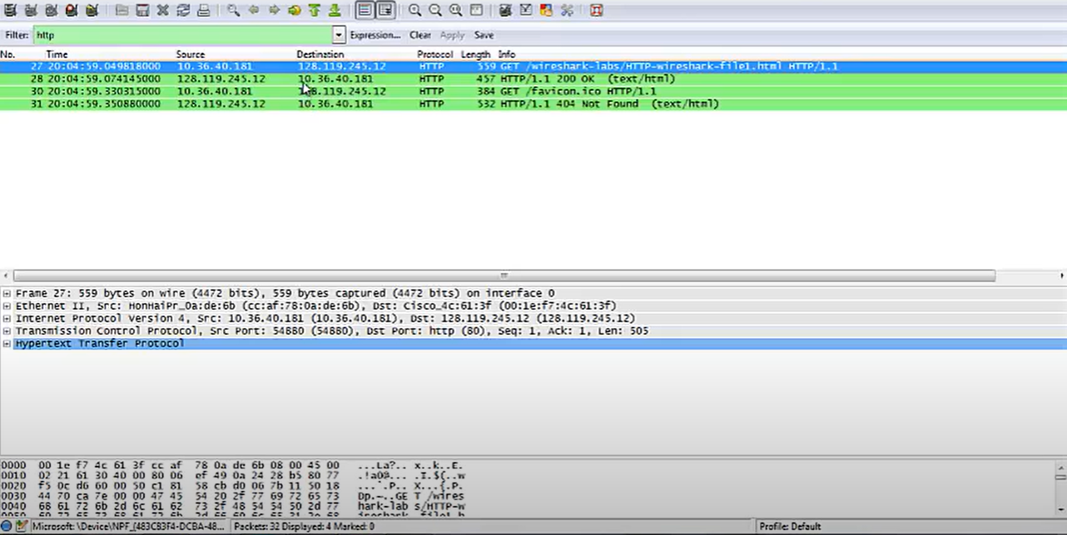

2. The HTTP CONDITIONAL GET/response interaction

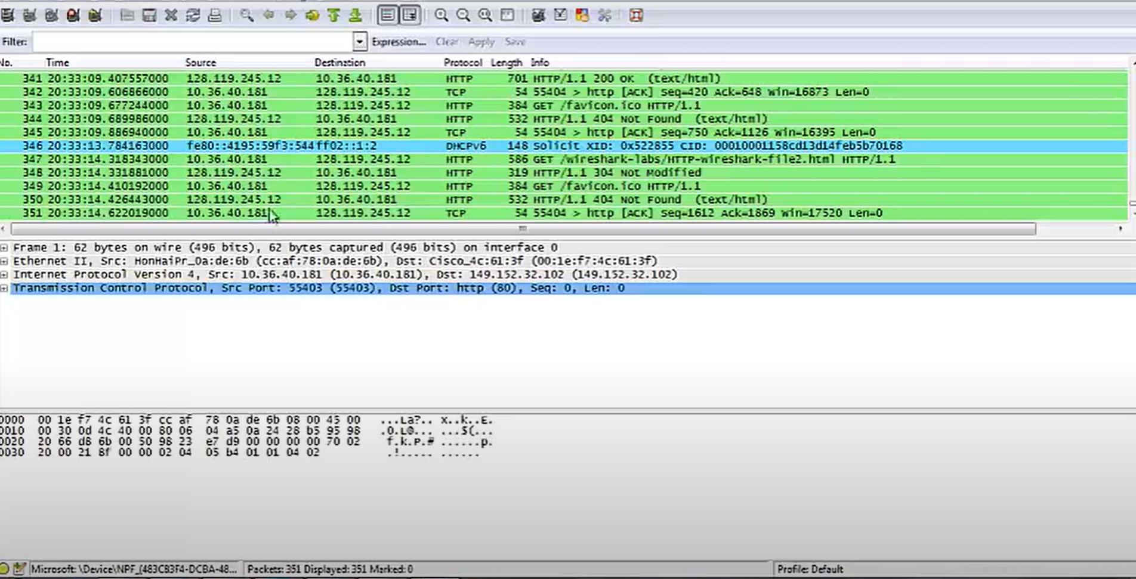

3. Retrieving Long Documents

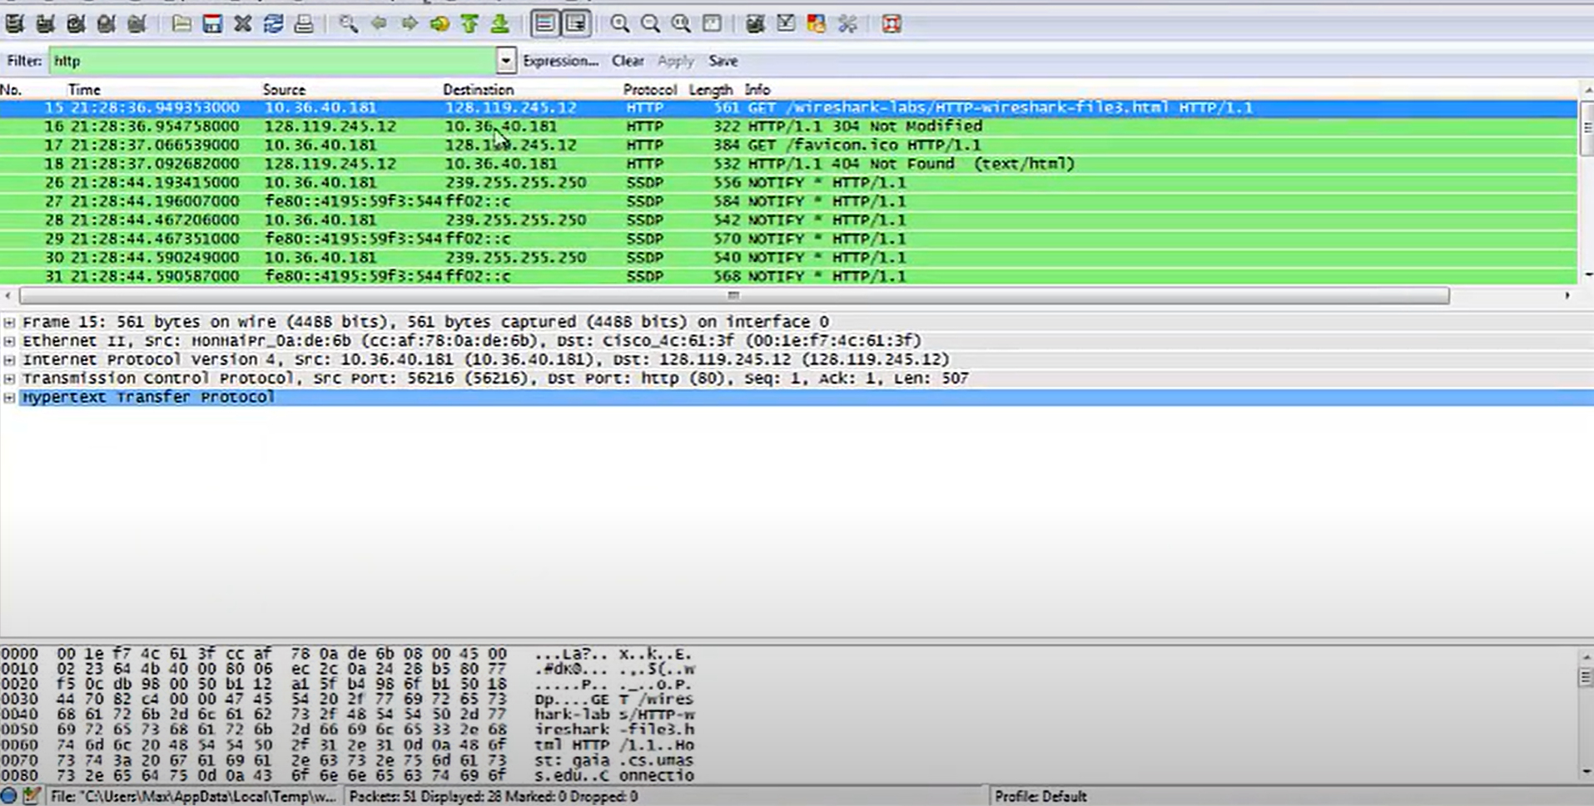

4. HTML Documents with Embedded Objects

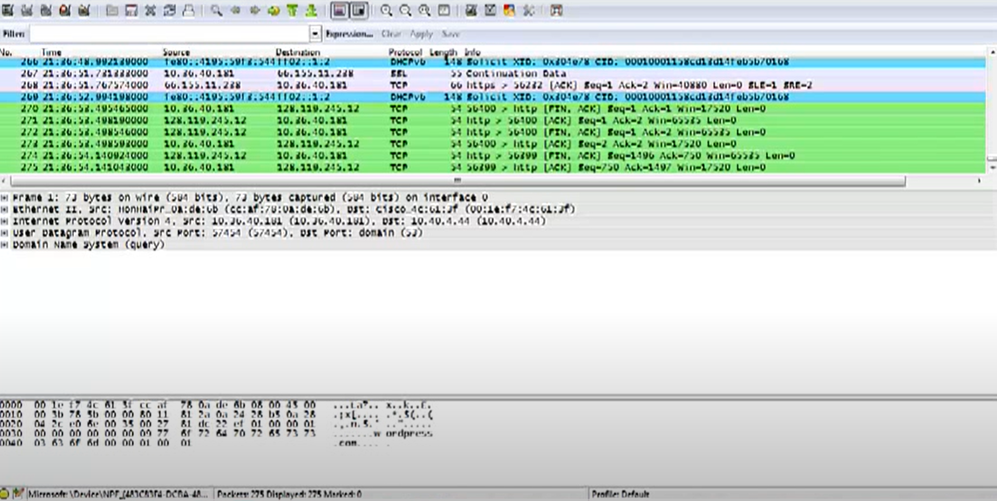

5 HTTP Authentication

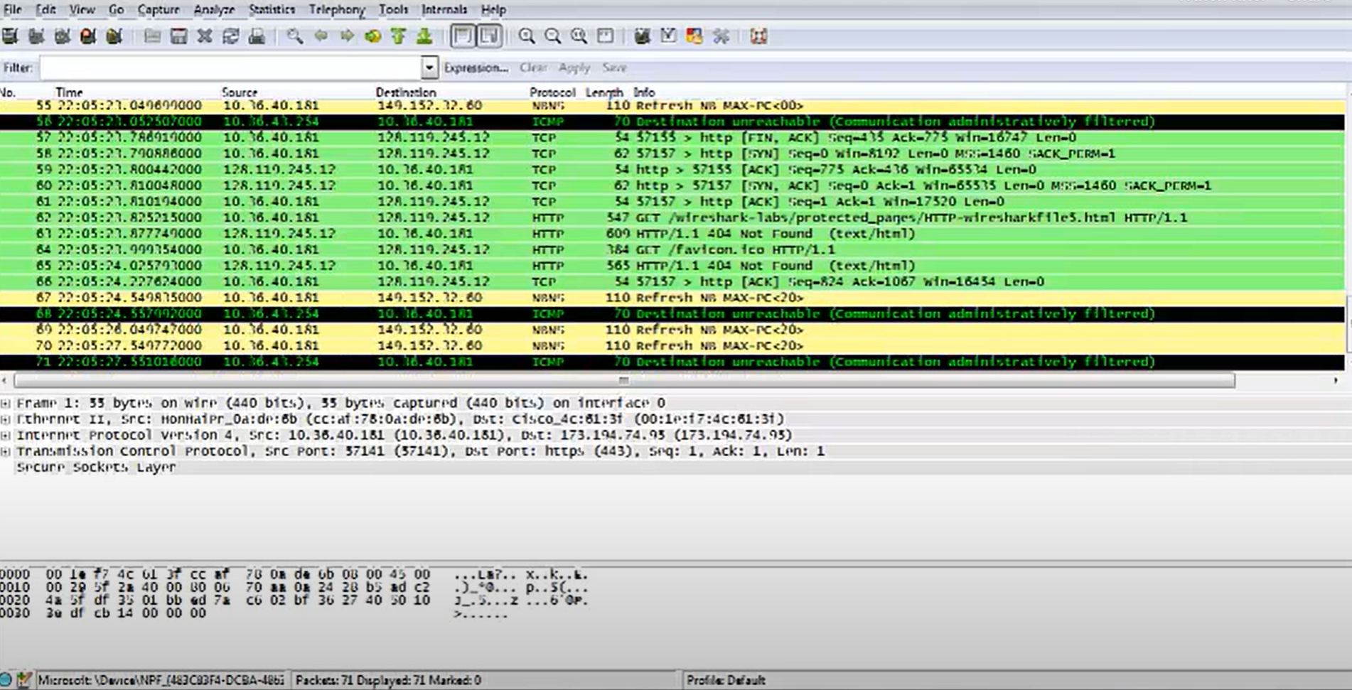

**Executing few commands to trace packets in Ubuntu via the terminal :**

1. ping

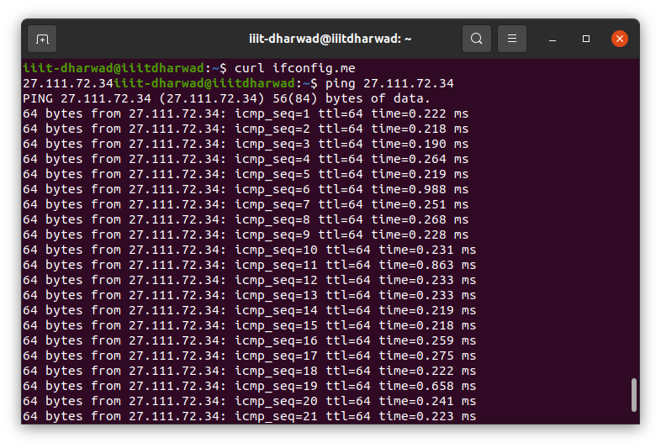

1. traceroute

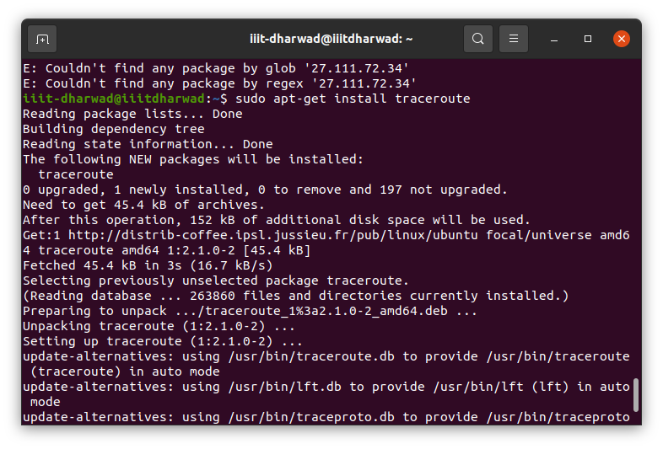

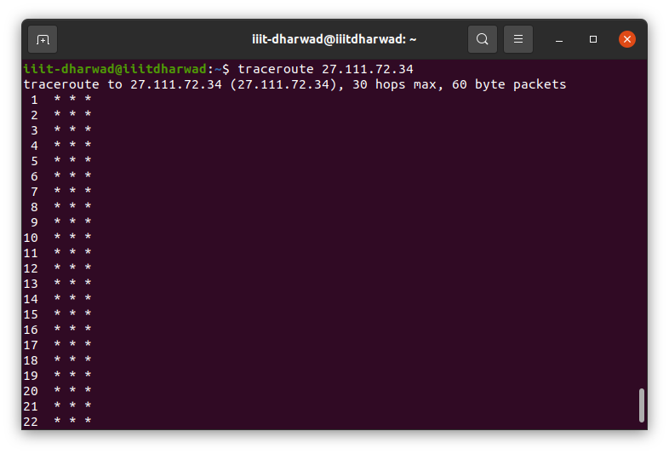

1. tracepath

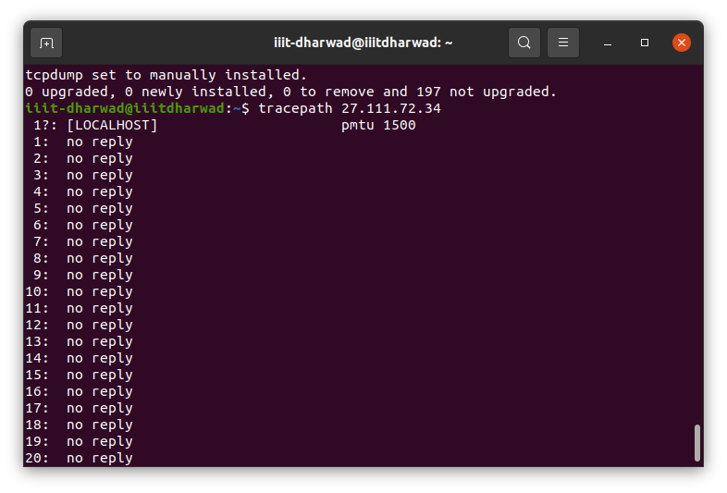

1. tcpdump

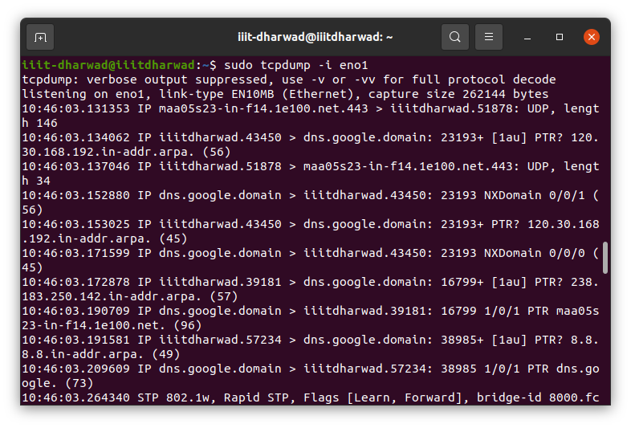



1. Installing tshark -> *sudo apt-get install tshark*

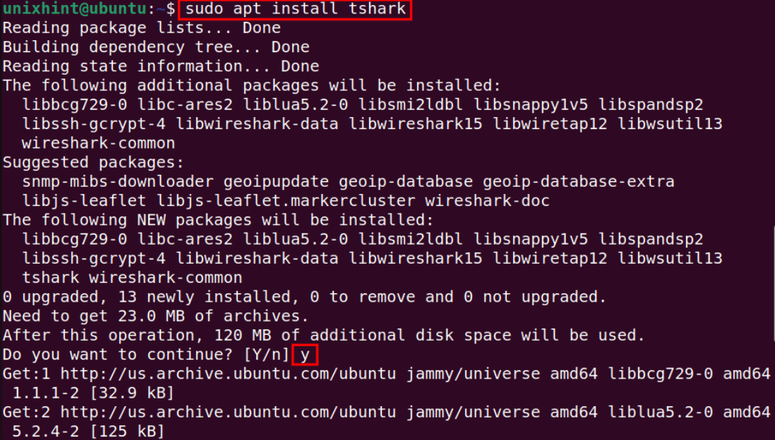

1. Basic usage

List Available Interfaces -> *tshark -D*

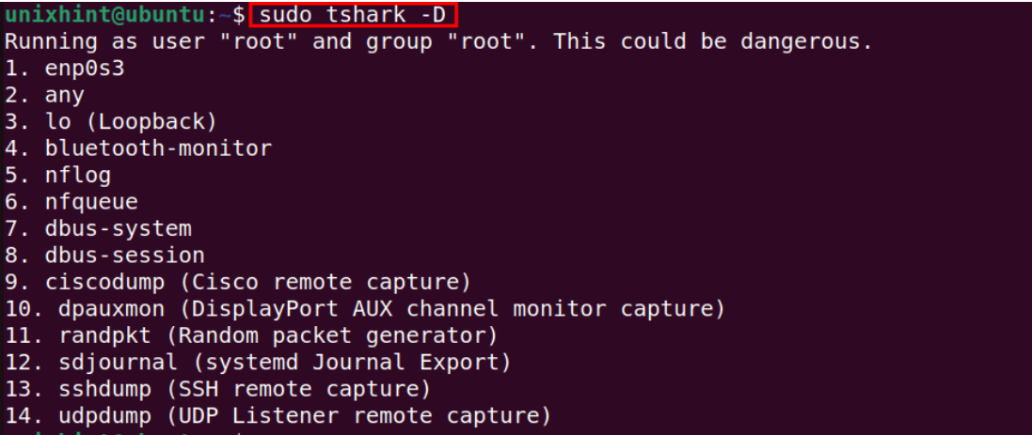

Capture Packets from all Interfaces -> *sudo tshark -i any*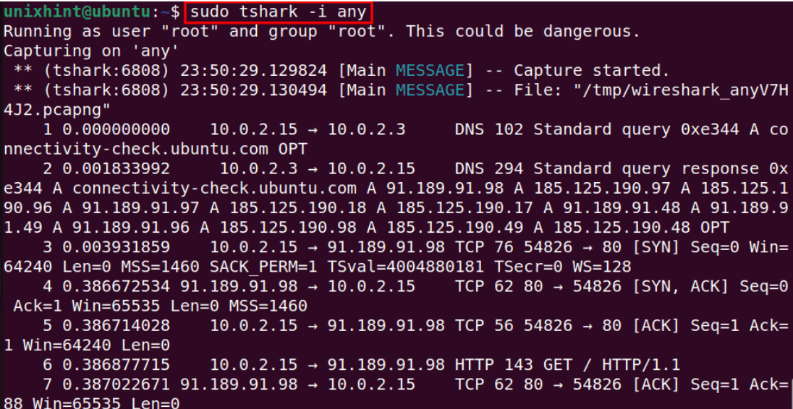

Capture Packets from a particular interface -> *sudo tshark -i enp0s3 -c 5